**Australian Passport Adult Simplified Renewal (PC7) Checklist for Mailed-In Applications**

|  |  |
| --- | --- |
| **NAME OF APPLICANT:** | |
| **You must be able to tick YES to all points 1 to 5 before mailing us your application** | **Checkmark with solid fill** |
| 1. **INSTRUCTIONS**: I have read the application and printing instructions on the [Embassy website](https://germany.embassy.gov.au/beln/applications_by_post.html). |  |
| 1. **APPLICATION FORM**: I have correctly completed and printed my [Renewal Passport Application form](https://www.passports.gov.au/apply-or-renew) online |  |
| * 1. My form is printed **ONE-SIDED** and **not cut off** at the top/bottom of the page as per the image. The barcode in the top right corner has printed correctly. |  |
| * 1. I have signed **inside** the signature box using **black** ink as per the image. |  |
| 1. **PHOTOS**: I have included **two identical** passport photos that meet the requirements listed on the [Australian Passport Office](https://www.passports.gov.au/getting-passport-how-it-works/photo-requirements) website. |  |
| * 1. I have written my full name on the back of one photo using **black** ink. There is no ink smudged on the second photo. A guarantor for your application and photos is not required |  |
| * 1. My photos are protected in a separate envelope or plastic sleeve. **DO NOT attach** your photos to the form which could damage them. We will attach them for you. |  |
| * 1. Recommended - I have emailed a digital image (the **original JPEG digital image** only - scans of the photo are not accepted) to: beln.passports@dfat.gov.au |  |
| 1. **PAYMENT**: I have included the completed and signed credit card authorisation form. If you don’t have a credit card another person can complete the credit card authorisation form. |  |
| 1. **COVER SHEET**: I have printed and am including this completed checklist. |  |
| **IMPORTANT: If you did not tick YES to all points 1 to 5 then carefully check your application or start again.**  **Incomplete applications will be returned to you unprocessed.** | |

|  |
| --- |
| 1. **Please advise of any travel that may impact the receipt of your new passport by registered mail:**  Travel from to: |

|  |  |  |  |
| --- | --- | --- | --- |
| **Mark items to charge:** | Passport Application, overseas processing surcharge and postage | Notarial fee and postage | |
| **Card Holder’s**  **Name:** | I, ___________________________________________________________________,  WRITE NAME ABOVE  - authorise the Australian Embassy Berlin to charge my credit card for the items marked above. I understand that **all fees are charged in AUD** and are subject to exchange rates and any overseas transaction fees. I understand that my card will be charged the fees applicable on the day the payment is processed. | | |
| **Signature:** |  | | **Date:** |

Passport and Notarial fees can be found at: <https://germany.embassy.gov.au/beln/Fees.html>.

**CREDIT CARD DETAILS**

|  |
| --- |
| **Type of card: Visa MasterCard** (No other credit cards accepted) |
| **Card Number:**  **Expiry Date:**  **CCV/Security Code:** |
| **Name on credit card:** |
| **Billing address:**  **Street/No:** ____________________________________________________________________________  **City:** _________________________________ **Post Code**: ___________________________  **Phone:** ______________________________________  **Email:** ____________________________________________ |

**If you do not have a credit card, and you do not know anyone who can pay with their credit card on your behalf, please tick this box and we will contact you by email with an alternative payment method. Please note that this will increase the application processing time by up to two weeks.**

**ADDITIONAL INFORMATION**

**SIGNATURE:** Sign and date the application form using **BLACK** ink - ensure your signature is within the white signature box. If your signature extends outside of the white box or touches words around the box, try again using the white box on the right-hand side) **or reprint a new form (one-sided)** and sign again. **IMPORTANT** - This is the signature that will show in your new passport.

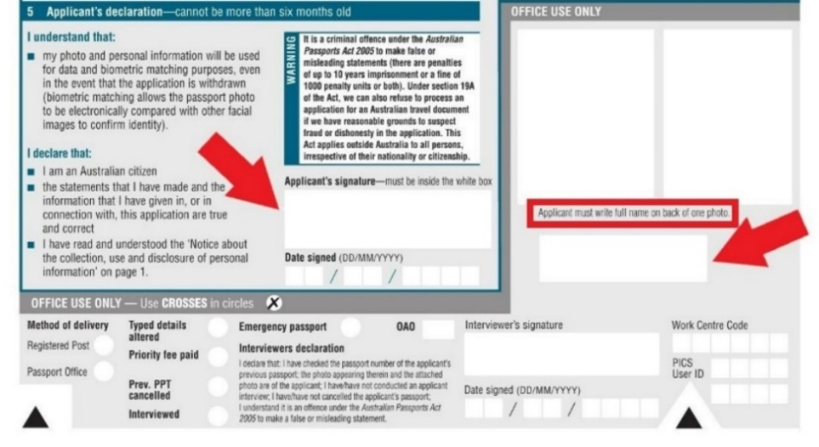See example below (this section must NOT contain any alterations or whiteout).

**WHERE TO SEND AND WHAT TO INCLUDE:**

Send your completed and signed application form, two photos, the credit card authorisation form, and this completed checklist to:

Australian Embassy Berlin

Passport Office

Wallstraße 76-79

10179 Berlin

**PLEASE DO NOT:**

* Print double-sided or the top/bottom of the form is missing or cut off.
* Use whiteout, staples, tape, glue or paperclips or anything else on any part of your mailed-in application or photos.

**APPLICATION PROCESSING TIMES:**

Check our website for [current passport processing timeframes](https://germany.embassy.gov.au/beln/passport_applications.html). To minimise processing times, make sure your application includes everything we need.

If applicable - Your **current/expiring passport** will be automatically cancelled 30 days from the date we send you the new passport. You will receive an email notification.

The new passport will be sent to the address provided on the application form by registered mail.